# Section 1: Climate Change Impacts, Exposures, and Vulnerability

## 1.1 Health and heat

### Indicator 1.1.1: Exposure of Vulnerable Populations to heatwaves

Authors: Federico Tartarini, Ollie Jay

Headline Finding

Analysis of long-term trends shows a 254% increase in total heatwave exposure, rising from 460 million person-days in 1991-2000 to 1.63 billion person-days in 2015-2024.

Geographic Coverage of Europe

This indicator encompasses all European Environment Agency (EEA) member and cooperating countries, as well as the United Kingdom of Great Britain and Northern Ireland.

Data

* **Climate data:** We utilized ERA5 Land reanalysis data at 0.1° resolution. For each grid cell, we calculated the annual number of heatwave days.
* **Vulnerable population assessment:** We developed spatiotemporal demographic data using NASA SEDAC GPWv4 and Eurostat datasets. The spatial distribution of age demographics from 2010 was obtained from GPWv4. We projected Eurostat demographic census data mapped to NUTS2 regions (2016 definition) onto the grid, adjusting demographic proportions per grid cell for the years 2000-2021 relative to the 2010 baseline. Infant population was estimated by calculating the difference between total births and infant mortality. For missing Eurostat demographic, birth, and infant mortality data, we applied gap-filling methods using the most recent available preceding year data, followed by subsequent year data when necessary (forward-fill followed by back-fill)

Methods

Heatwaves are defined as periods of 2 or more consecutive days during which both minimum and maximum temperatures exceed the 95th percentile of the local climatology (REF) established using the 1991-200 baseline period. The vulnerable population comprises individuals aged 65 and older, along with infants under one year of age—demographic groups that extensive research has identified as particularly susceptible to adverse health effects during heatwaves (REF). Exposure was quantified by multiplying the number of heatwave days by the vulnerable population count, yielding an indicator measured in "person-days." This metric effectively captures both the changing frequency and duration of heatwave events across the study period.

The analysis was conducted using Python, with all code available in a public repository: https://github.com/FedericoTartarini/paper-lancet-countdown-europe. To reproduce these results, users should first download the required datasets, then follow the detailed instructions provided in the repository's README file. The documentation includes comprehensive step-by-step guidance for executing the Python code and generating the complete analysis.

Caveats

To estimate demographic changes over time, we integrated data from multiple sources to capture both spatial distribution and temporal evolution of population characteristics. This combined methodology, while comprehensive, has undergone limited validation procedures.

Future Form of the Indicator

This analysis will be updated annually using the most recent climate and population datasets. Future iterations may expand to include additional vulnerable demographics, such as pregnant women and individuals with chronic conditions who affect their ability to cope with the heat.

The heatwave definition may be refined to align with emerging standardization efforts by organizations like the World Meteorological Organization. Additionally, we plan to incorporate other environmental factors that influence human heat stress risk, particularly humidity, to provide a more comprehensive assessment of exposure.

Additional analysis

Figure 1 illustrates the mean annual number of heatwave days experienced by vulnerable populations (elderly individuals and infants) across each Nomenclature of Territorial Units for Statistics (NUTS) region during both the baseline period (1991-2000) and the comparison period (2015-2024). While heatwave frequency increased universally across all regions, Southern and Eastern Europe, along with Western Asia, experienced the most pronounced increases. Notably, several NUTS regions recorded more than 30 heatwave days annually during the 2015-2024 period.

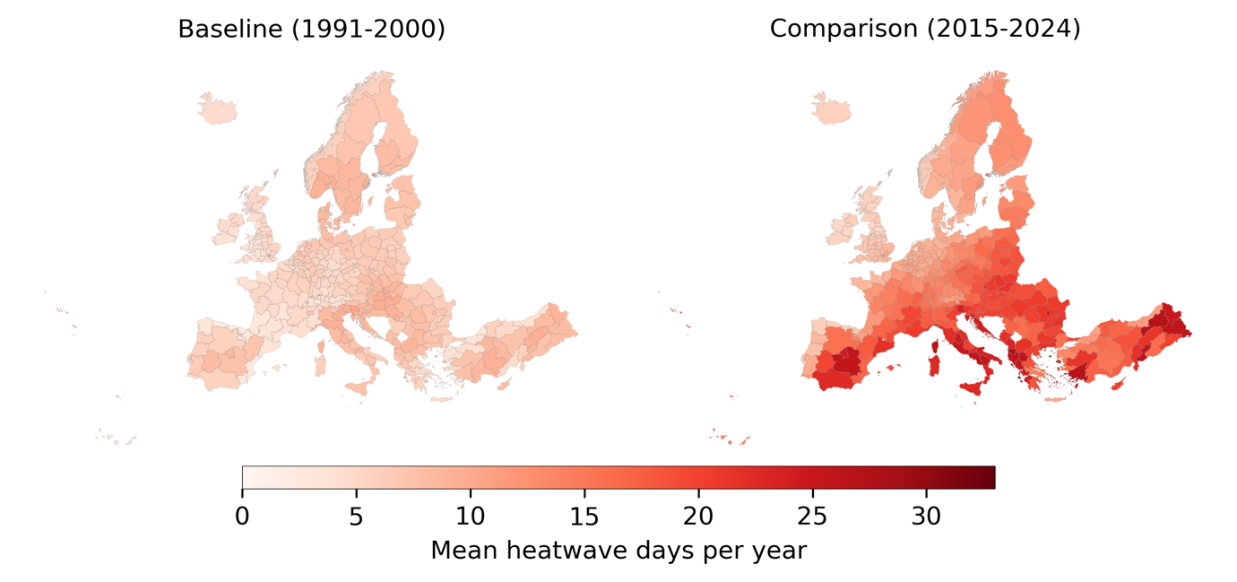

Figure 1: Mean Annual Heatwave Days Experienced by Vulnerable Populations During Baseline (1991-2000) and Comparison (2015-2024) Periods.

Figure 1 aggregates data over a ten-year period, we present the heatwave exposure among vulnerable populations in 2024 in Figure 2. To enhance visual clarity, we adjusted the maximum threshold in the colour bar, as some NUTS regions experienced over 60 heatwave days—nearly double the mean value observed during the comparison period.

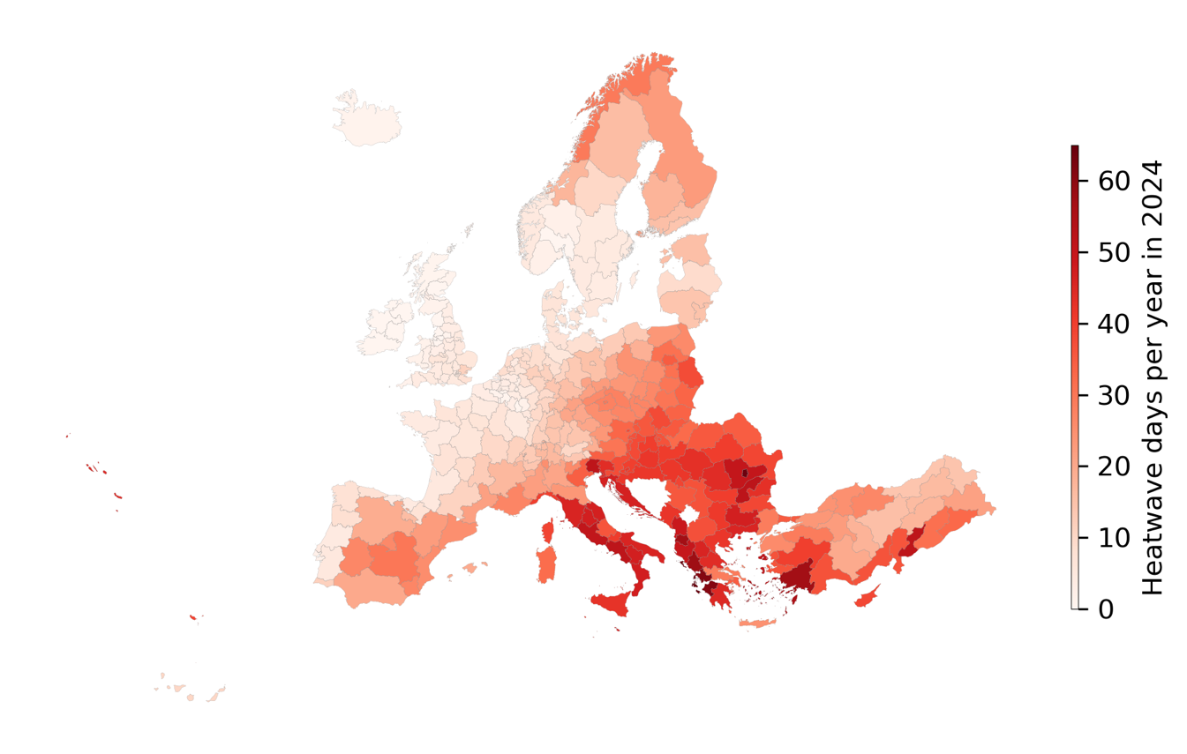

Figure 2: Heatwave Day Exposure Among Vulnerable Populations in 2024. Note: This visualization employs a modified color scale (increased max value) compared to previous figures to enhance visual interpretation.

Figure 3 depicts the change in heatwave exposure, measured in excess person-days, for both vulnerable groups. Over the past three years, older adults have experienced an annual increase of more than 1.4 billion person-days compared to the baseline period (1991–2000) - surpassing the values recorded in all previous years since 1991. The corresponding annual totals of heatwave person-days are shown in Figure 4.

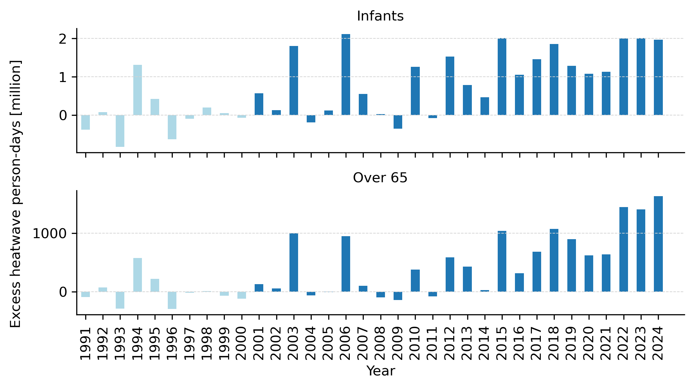

Figure 3: Excess Heatwaves Person-Days (Relative To 1991-2000 Baseline – Light Blue Bars) for Infants and Over 65.

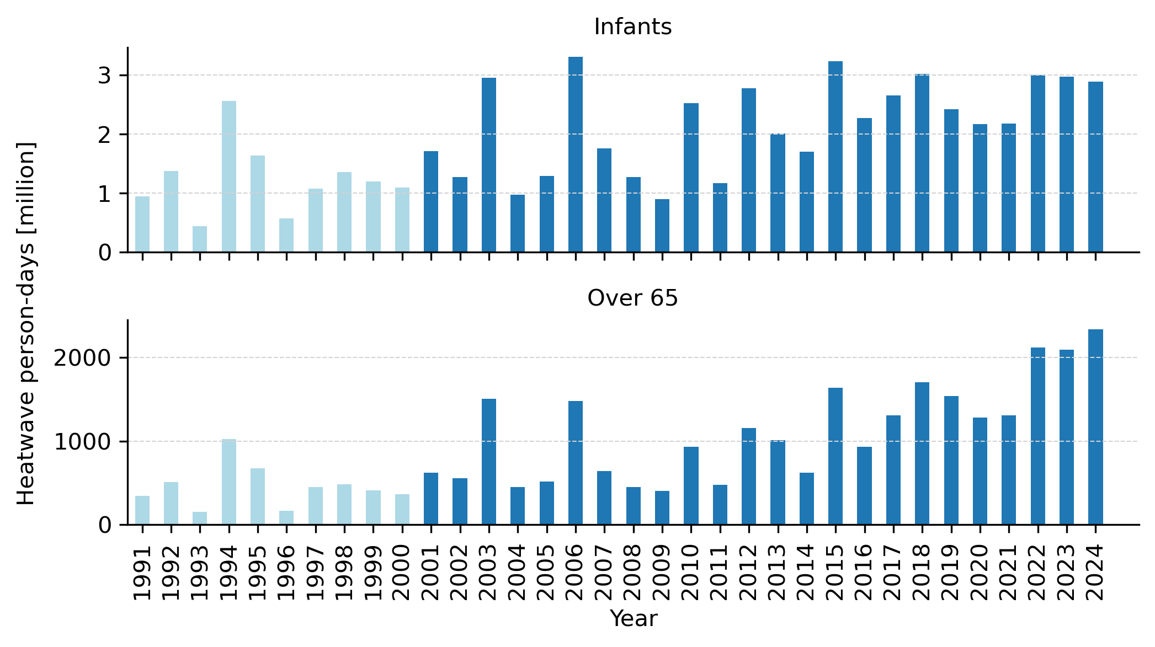

Figure 4: Total Heatwaves Person-Days (Relative To 1991-2000 Baseline – Light Blue Bars) for Infants and Over 65.

We normalised the data in Figure 4 by dividing exposure by the total population and present the results in Figure 5. This figure reveals that both older adults and infants were exposed to more than twice the number of heatwave days compared to the European average. Hence, these groups are not only more physiologically vulnerable but also experienced disproportionately higher exposure. Notably, in 2024, older adults experienced more than 20 heatwave days per year for the first time on record.

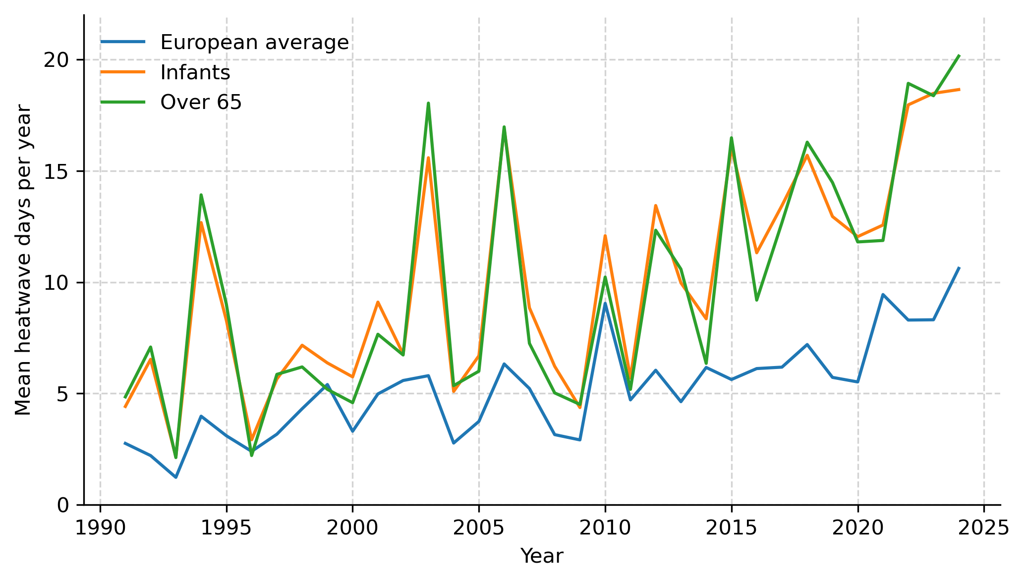

Figure 5: Mean Heatwave Days Per Person.

Figure 5, however, does not show the geographical distribution of heatwaves exposure across different regions. We, therefore, decided to plot the mean heatwaves days per year in Figure 6. Eastern and Southern Europe, and Western Asia were the most affected regions where vulnerable groups where exposed to more than 15 days of heatwave per year since 2021. In 2024, older adults in Eastern Europe for the first time since 2000 experienced 34.5 days of heatwaves.



Figure 6: Mean Heatwaves Days per Person per Region

The change in heatwave exposures from 1991-2000 to 2015-2024 of over 65 and infants by grid cell is shown in Figure 7 and Figure 8, respectively.

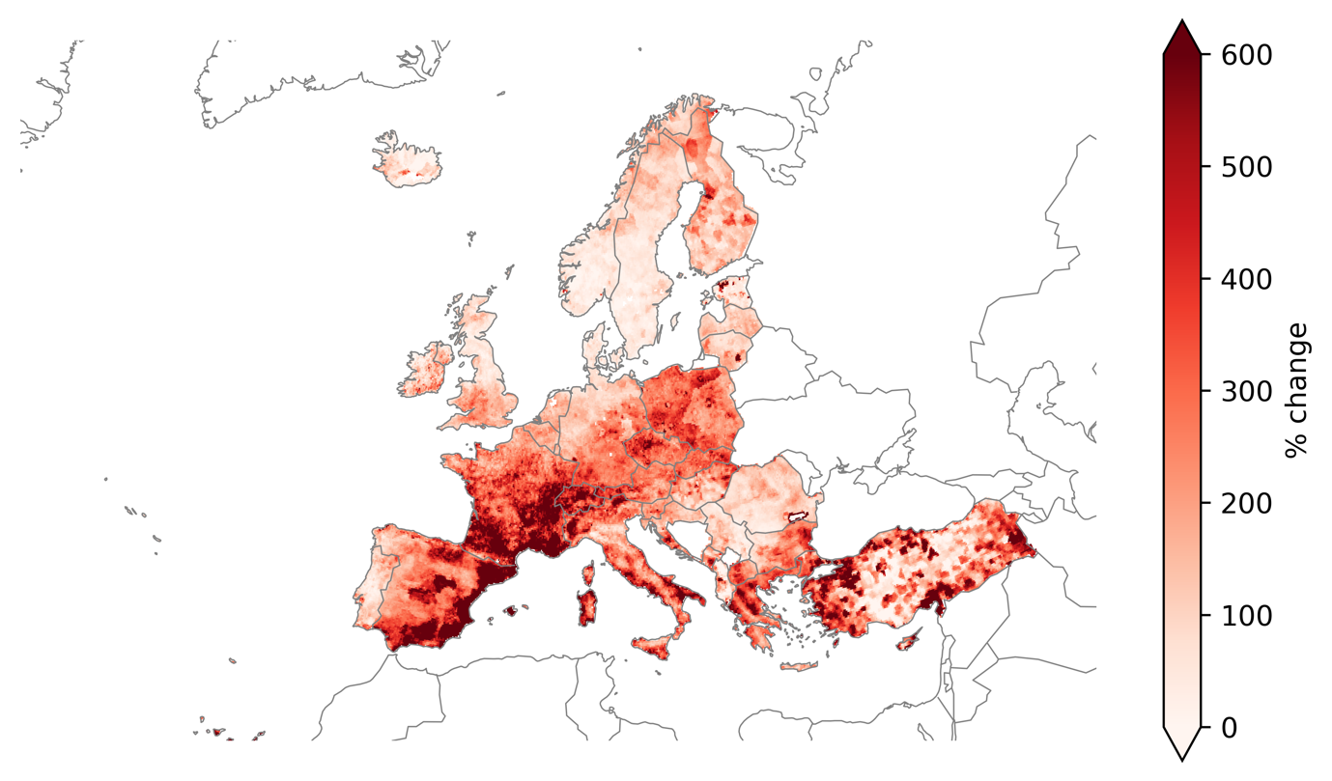

Figure 7: Change in Heatwave Exposures of Over 65 from the Baseline Period (1991-2000) to the Last Decade (2015-2024) by Grid Cell.

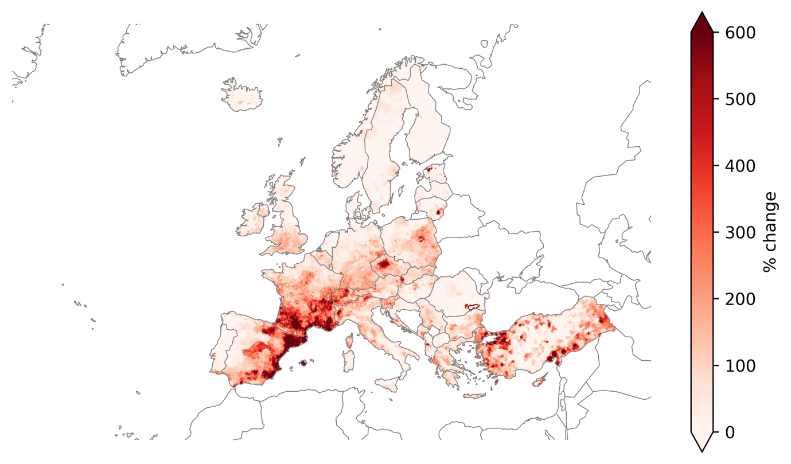

Figure 8: Change in Heatwave Exposures of Infants from the Baseline Period (1991-2000) to the Last Decade (2015-2024) by Grid Cell.